**Student Name: Student ID:**

**Lecture Exercise in Week 10**

Compute the shortest paths from vertex A (the source) to any other vertices in the following graph. (Is there any negative weight cycle?)

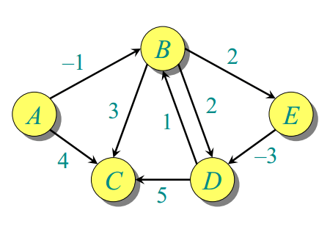

**Solution:**

|  |  |  |  |  |  |
| --- | --- | --- | --- | --- | --- |
|  | **A** | **B** | **C** | **D** | **E** |
| **i=0** | **0/NIL** | $$∞/NIL$$ | $$∞/NIL$$ |  |  |
| **i=1** |  |  |  |  |  |
| **i=2** |  |  |  |  |  |
| **i=3** |  |  |  |  |  |
| **i=4** |  |  |  |  |  |
| **I=5** |  |  |  |  |  |

(Why we need 5 iterations?)